
NEWSLETTER – JANUARY 2015
Contents
Chairman’s message
Programme of Events, January–June 2015
Annual Subscriptions 2015
Social media update – Louise Coffey
Bayreuth Diary 2014 – A personal view – Jarlath Jennings
Die Meistersinger in dem Doppelte!! – Jarlath Jennings
Book Review: Paul Dawson-Bowling, The Wagner Experience: And its Meaning to
Us – by Dame Gwyneth Jones
Church of St Martha, Nuremberg – Stephen Mennell
Wagner on Lyric FM – Stephen Mennell
14
15
1
2
2
3
3
8
11
Chairman’s message
Dear Member,
First on behalf of the Committee let me wish you a very Happy New Year.
We have started the year with a wonderful talk by Michael Murphy. Unfortunately
I could not make it myself, but I have heard great reports that make me jealous of those of
you who were there. Hopefully the rest of the talks this year will be as interesting. We are
soon off on our trip to Zürich, and given the recent move in the Swiss Franc it may be our
only trip there for some time. Luckily we had the tickets purchased before the currency move.
We will also soon be finalising our trip to Leipzig in May. If you are interested and have not
yet contracted me please do so as soon as possible. Even if you are only contemplating it as
this stage, get in contact, because you have some time yet before a final decision has to be
made, but we are holding only a limited number of tickets.
Lastly can I remind you to pay your subscription if you have not already done so? We look

2
forward to seeing you at events this year.
Kind regards
Anthony Linehan
Chairman
Programme of Events, January–June 2015
Unless otherwise stated, all events take place at our usual venue, the United Arts Club, 3
Upper Fitzwilliam Street, Dublin 2, starting at 8.00 p.m.
Thursday 15 January: Michael Murphy, University of Limerick, on ‘Public perceptions of
Wagner performances in Ireland, 1860–1920’
31 January–4 February: Society trip to Zŭrich for Tristan und Isolde and Norma
Saturday/Sunday 21–22 February: Derek Watson, Workshop on Siegfried
Saturday: 10.00 a.m. to 7.00 p.m.
Sunday: 10.00 a.m. to 5.00 p.m.
Note: The fee will be €35, payable on the day, and members are asked to let us know
(info@wagnersociety.ie) if they wish to attend, so that we have some idea of
numbers.
Tuesday 24 February: Live broadcast of Der fliegende Holländer from the Royal Opera
House, Covent Garden, London – in cinemas countrywide. Please check local listings.
Thursday 5 March: Annual General Meeting
Thursday 23 April: Wolfgang Marx, UCD, on ‘Albert Lortzing: Hans Sachs and the first
Meistersinger’.
14–17 May: Annual Congress of the Richard Wagner Verband International, Dessau,
Germany. Programme includes a complete cycle of Der Ring des Nibelungen and many other
events.
21–25 May: Society trip to Leipzig: performances of Parsifal, Das Liebesverbot and
Siegfried
Annual Subscriptions 2015
The Treasurer, Mary Spollen, would like to thank all those who have already paid their
subscriptions for 2015 and to remind those who have not yet done so that subscriptions are
now due. The Annual Subscription for 2015 is €50. Details of the payment options are to be
found in the email sent on 8 January 2015.

3
Social media update
Our Facebook group is now up and running. If anyone would like to join the page for
updates, reviews and photo sharing, or if anyone has any reviews or photos that they would
like to share with the society, please email info@wagnersociety.ie. Members are reminded
that anything shared on the Society’s Facebook page is visible only to other members of The
Wagner Society of Ireland.
Louise Coffey
Bayreuth Diary 2014 – A Personal View
Jarlath Jennings
1 Introduction
I had a very enjoyable seven-day trip to Bayreuth in late July–early August last year. The
primary purpose of my visit was to see the very controversial Frank Castorf production of
Der Ring des Nibelungen. However I got an additional surprise in the post in May 2014. My
request for a ticket to Lohengrin resulted in a late allocation. All tickets were sourced via the
Friends of Bayreuth (Gesellschaft der Freunde von Bayreuth). Through their good offices I
have seen all five ‘current’ productions between 2013 and 2014.
For the productions this year I was alone! That is to say, I was not with a Wagner Society
group among whom we could discuss the productions and have an enjoyable social time. I
say this not to look for your pity (!) but to emphasise the great added value that one gets as
part of a group or society and how important this feeling of community is. The benefit from
this solo experience is that it forced me to meet new people and engage in conversations
which shed unique perspectives and insights regarding the productions.
All five Bayreuth 2014 productions could be described as avant garde. From what I can see,
forthcoming productions from 2016 onward fit the same bill – so even if Katharina Wagner
steps down from her role in 2020 (and there is absolutely no evidence to suggest she will) we
will be faced with challenging productions for the foreseeable future. I recommend you look
into attending Bayreuth despite any misgivings you have about these productions. The good
points of Bayreuth far outweigh the bad. Having made this recommendation and before you
have had a chance to read a word of my review I can confirm that, if I am lucky enough to be
allocated a ticket, I will return to Bayreuth before the end of the Castorf Ring to learn more
about it and appreciate the wonderful music and sublime acoustic of the Festspielhaus.
2 Lohengrin: Second Thoughts
The Hans Neuenfels production was launched to controversy in 2010. Jonas Kaufmann sang
the title role for the first year. When I first saw this production on 20 August 2011 I was with
a small group from the Wagner Society of Ireland and we really enjoyed it. I can honestly say
I enjoyed it as much, if not more, when I saw the production again on 31 July 2014. This was
the fifth year of the production. Klaus Florian Vogt was wonderful as Lohengrin, and really
looked the part of the Swan Prince. Edith Haller played Elsa von Brabant and her singing was
4
absolutely beautiful. Haller’s voice was particularly effective in the higher register and her
singing was delightful especially in the scenes with Petra Lang. (My notes from 2011 had
some mild criticism of the small voice of Annette Dasch who sang Elsa.) Petra Lang was
excellent as the scheming Ortrud and if there was a relative weak link it was Tomas
Tomasson singing Friedrich. A word of praise has to go to Samuel Youn as Der Heerrufer
des Königs, where he was effective in the way he seemed to marshal and control the
choreography of the chorus. And speaking of the chorus, words cannot express the effect of
this wonderful group in full flight. Truly, truly wonderful.
In its initial year this production was lambasted. Yet it seems to have grown in fondness to
audiences over the years since 2010. Neuenfels is a very experienced director, and at the age
of 69 was making his Bayreuth debut. The colour, the choreography, the technical support,
sometimes mid-scene and mid-number, made this delightful to watch. I also saw Lohengrin
wedged between Siegfried and Götterdämmerung so this probably accentuated the lightness!!
After a five-year run, Lohengrin has been awarded an extension and will run for one more
year in 2015. Tannhäuser (great music and chorus, but a production beyond redemption!)
will make way for it and finish early after a four-year run. If you can, I urge you to see this
production of Lohengrin. If you cannot, I urge you to buy it on DVD. Although there are
some cast improvements since the DVD was made during the 2011 Festival you can still
appreciate the spectacle and the voices of Vogt and Lang are here as well as the chorus and
the wonderful conducting of Andris Nelsons
3 Der Ring des Nibelungen
a. Preface
This was my second Ring Cycle in eight weeks. I really enjoyed the Ring in Budapest and
must say I was apprehensive about Bayreuth, given the amount of negative press it received
when it was launched in 2013. I thought of naming this review ‘The Good, The Bad and the
Ugly’ to cover all aspects of the production! As a former market researcher I even allocated
marks against my three descriptors with ‘Good’ achieving 68 marks, ‘Bad’ 12 marks and
‘Ugly’ 20 marks! However I looked at a different type of deconstruction for this review,
which I hope will get my views across and allow you make a decision whether or not to
attend this production before the end of its run.
b. Kirill Petrenko
Kirill Petrenko and the Festspielhaus Orchestra were absolutely wonderful, from the first note
of Rheingold to the last note of Götterdämmerung. The pace was fast and furious. More than
an hour faster than the previous Bayreuth (Dorst) Ring, which Christian Thielemann was
conducting. This was my fifth Ring cycle, my second at Bayreuth, and I was starting to see
the cumulative effect of my Wagner Ring cycle investment! Petrenko could get the beauty of
the music across, whether it was hugely dramatic moments like the Ride of the Valkyries or
subtle moments like the Woodbird in Siegfried. My only criticism of the orchestra was that
they didn’t take a curtain call at the end of the cycle so the ecstatic audience could show their
appreciation. Maybe they only do this at the end of cycle 3 of the Ring each year, or maybe it
was the delay getting to the stage last year as Castorf faced sustained booing, I don’t know
the answer to this. What I do know is that this conductor is worth the admission price alone –
high and all as it is.
5
c. The Singers
The quality of singing was extremely high. Apart from a little booing for Oleg Byjak in the
curtain call after Siegfried, there was great acclaim and appreciation for the singers
throughout the cycle. Ironically Byjak, who sang the role of Alberich, got a good reception
after Rhinegold and Götterdämmerung!
Wolfgang Koch sang the role of Wotan and the Wanderer with great authority. Lance Ryan
was excellent as Siegfried, though I thought he gave a better performance in
Götterdämmerung than in Siegfried. I didn’t know how Catherine Foster would fare as
Brunnhilde. There were mixed reports of her performance in 2013. However, she didn’t
disappoint and her performance got stronger right up to the immolation scene in
Götterdämmerung. I also wondered how Johan Botha would fare as Siegmund, but I needn’t
have worried. He was excellent and,, surprisingly, was very believable as the young lover in
Act 1 of Die Walküre. Other good voices worthy of specific mention are Mirella Hagen
(Woglinde and Waldvogel); Kwangchul Yuon (Hunding); Nadine Weissmann (Erda);
Burkhard Ulrich (Mime); and Elisabet Strid (Freia). There is one voice I haven’t mentioned
yet and it was the voice that got the biggest, most responsive reaction from the audience:
Anja Kampe (Elsa von Brabant), whom we all raved about in Budapest, who put in a similar
performance Bayreuth. She was absolutely magnificent ... again!
d. The Set
It is hard to visualise the sheer scale of the set so I have decided to do a separate section on
this prior to talking about the production. Each of the four operas had a different 360 degree
set. The set was on a turntable and moved regularly and effortlessly both between and during
scenes. An example of this was seen when Siegfried was not carried off the stage during the
funeral march. Instead the set moved 90 degrees anticlockwise taking him offstage (don’t
worry, he was carried back on a short while later!).
There was a torrential rainstorm (outside!) on the day I attended Die Walküre. To permit a
timely start (and the opera did start on time) many of the audience taking shelter towards the
rear of the Festspielhaus were allowed to take a dry shortcut through what seems to have been
a props store room. That brought us up close and personal to many of the props used for
Rheingold and Siegfried and I can only describe them as huge. These props were put in place
each day and they worked seamlessly like a premium German automobile. I cannot think of
any opera house anywhere in the world that could produce sets to the same scale, efficiency
and high standards as this production in Bayreuth.
While I haven’t been in the Russian oilfields, I was impressed with the multiple level staging
of this set in Die Walküre. I have been in Alexanderplatz when it involved passing through
Checkpoint Charlie into East Berlin. I have stayed in a crummy hotel on Route 66 in the
Texas Panhandle. I have been to the New York Stock Exchange and I did venture to South
Dakota in 2013 to see Mount Rushmore. The sets that represent these are major triumphs of
stage engineering and mostly work well. Action frequently takes place on 4 or 5 levels
simultaneously from the stage floor to the top of the proscenium arch. Not content with this
the sets are also often embellished with video footage, and in the Mount Rushmore set the
faces change not only to Marx, Lenin, Stalin and Mao but with video embellishment the
heads of Siegfried and The Wanderer replaced these infamous four for part of Act 2 of
Siegfried.
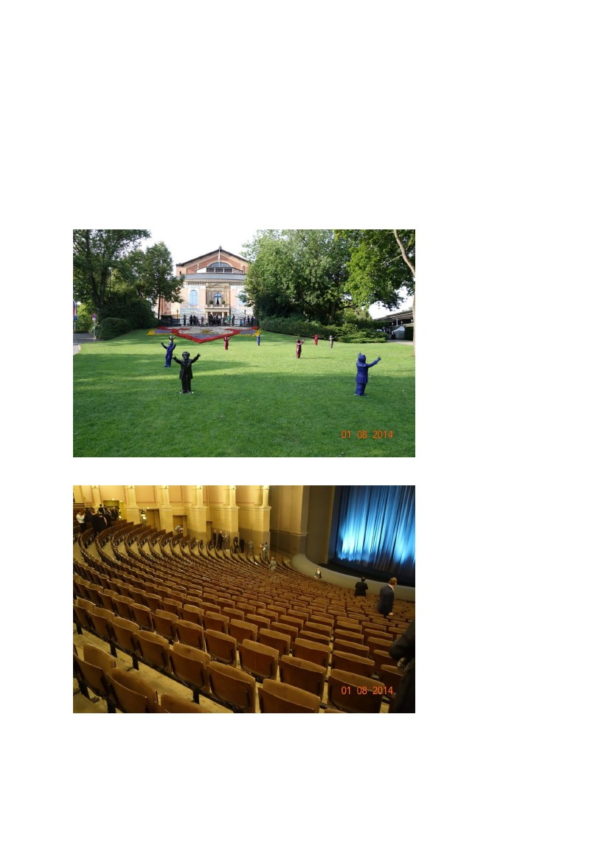
6
There were aspects that didn’t work. In Siegfried, Lance Ryan was singing at the top right
hand side of the set maybe 20–30 metres above the stage. Wolfgang Koch was singing on
stage and the orchestra was submerged below stage. Even the genius of Richard Wagner
would struggle acoustically with this!
One set that was a little strange was the set which represented the Hall of the Gibichungs in
Götterdämmerung.The representation was an industrial one with a little canteen. When the
choir were involved in this scene, the whole place looked quite congested and the logistics
seemed badly thought out. I had some difficulty with how gritty and grimy this scene looked
and also the Prologue of Götterdämmerung where the Three Norns were depicted as bag
ladies.
7
e. The production
I can’t claim to understand this production. There are parts of it that are bad and parts that are
downright ugly. Yet as well as this there are some parts that are stimulating, probing,
challenging and insightful.
The (mostly German) people I spoke to didn’t seem to feel the challenges that I had with the
production. One couple, sitting next to me, liked this production more than the previous Dorst
production because they felt there was a creative idea here, which was carried successfully
through the full cycle. The idea, in their view, was that this Ring production was all about the
clash of ideologies, particularly East versus West and how this tension can only end badly.
They felt that Castorf, with experience of both East and West, was in a good position to
interpret this.
Another person I spoke to was attending the Castorf Ring for the second year running. He
tried to explain the non-singing role of a Fool/Loser, put forward by the director. This chap
looked a little like the small bald guy in the Benny Hill TV shows of old. He was there to
dramatise the excesses that were taking place on stage and to show how futile these events
were. So in Siegfried he plays a waiter who brings out champagne continually and wastes it,
while Siegfried and Brünnhilde are singing in Act 3. I couldn’t understand what this
Fool/Loser added to the production, and he appeared in various guises throughout the four
operas. Much has also been made in the 2013 reviews about the appearance of two amorous
crocodiles in Act 3 of Siegfried. I hoped they would be axed in 2014, but no ... In 2014 there
are three crocodiles – our loving couple and their new baby croc. My new German friend
could hardly contain his laughter as he told me this.
In Rheingold a lot of use was made of cameras on stage, partially to provide additional video
footage and partially to reflect a sort of reality TV show. While it could be irritating, at times
it was also probing. And because the audience sometimes saw action to the front of the stage,
they also saw the characters in the back rooms (because this is a 360 degree set) after the
singers went off- stage.
There were some things I felt worked well. Personifying the Woodbird and having Mirella
Hagan, with a pair of wings worked for me. Also I found it easy to believe that a modern
Siegfried might have had a machine gun rather than a sword.
If the New York Times reviewer in 2013 (Anthony Tommasini) refused to catalogue the array
of sexual adventures in this production of the Ring. I will follow his lead. Suffice to say there
was a lot of sex in this production and a lot of it was presented in a boyish voyeuristic Fellini-
style way (with apologies to the Italian film director). Presumably when Castorf looked at the
libretto he saw a lot of sex. My view is twofold. Firstly there is no need to illustrate scenes
with sex ... and in many cases the sex isn’t even in the libretto. Secondly, I believe it is
degrading on the singers to have to ‘sing and snog’ on the number of occasions that the
production team have asked them to.
I have just looked at a video of the production team, including Frank Castorf taking a curtain
call after Götterdämmerung on 1 August, which I recorded as a souvenir (tut, tut!). While
there was a lot of booing from the audience there was also a lot of ‘bravos’. In fact I would
go so far as to say the ‘bravos’ won the day by a considerable margin. This seemed a lot
more tame than in 2013.There seemed to be a genuine rapport between Castorf and the
singers. Lance Ryan was quoted as saying:
I’ve never come across an audience with so much hatred, so much anger, and
a thirst for revenge. They take everything personally. It makes you feel a little
8
bit scared and its really quite terrifying.
As I left the Festspielhaus after Götterdämmerung – and I was one of the last to leave – there
was still a small group behind me clapping and bravoing.
f. The Last Word
I took extensive notes after each of the operas. I’ve been planning this article since I came
home on 2 August. As I finalised this review I have been listening to the performance of Die
Walküre I attended on 28 July, which was broadcast on German Radio and of which I was
lucky enough to have obtained a recording. There is a great deal to commend this Ring. All
the good things are very, very good. But the bad things are horrid! Thankfully there’s a lot
more good than horrid.
I hope this review helps you with your Bayreuth Festival planning for 2015 and beyond.
Die Meistersinger in dem Doppelte!!
Jarlath Jennings
New York, 9 December 2014
New York City in December is a very special place. No excuse is needed to visit this iconic
city but when the Otto Schenk production of Die Meistersinger von Nürnberg is having its
final outing, then the combination is unmissable! The revival for the last time of the work;
which was premiered in 1993, is to honour Fr Owen Lee. (His book ‘Wagner and the wonder
of art: An introduction to Die Meistersinger’ is an excellent reference)
At the heart of this wonderful opera is the conducting of James Levine. He has conducted
most of the performances at the Met in the last 21 years. His recent ill-health has been well
documented and he conducts with passion and control from a motorised wheelchair in the
adapted pit of the auditorium. It is a long evening for him, as he is on stage for pretty much
the full duration – including intervals. Some critics were scolding about his energy
consistency but I didn’t see this. His ability to get the best from the orchestra is mesmerising.
This is particularly evident as he moves from the overture to the opening chorus, but also in
the orchestral preludes. He can blend the orchestra, chorus and singers beautifullym, but I
was also taken by his work with some of the more delicate pieces, whether it was the two
harps or the tiny tinkle of the triangle. He makes this opera worth the trip alone. When I
asked one of the ushers about the length of the second interval she reverentially replied ‘35 to
40 minutes, the Maestro needs the time’. Well he is worth the time and more, even if the
evening runs to over 6 hours
Donald Palumbo does a splendid job with the Met Chorus and Meistersinger is a great
testament to his work. This chorus love this opera and this production and I am sure will be
disappointed that it won’t be back.
The Otto Schenk production follows the libretto instructions faithfully. The original staging
of Gunther Schneider-Siemssen and the stage direction of Paula Suozzi was spectacular. I
loved the initial curtain reveal of the choir and singers in Act 1. I also loved the configuration
of the table with the names of the master singers and their respective guilds. When the curtain
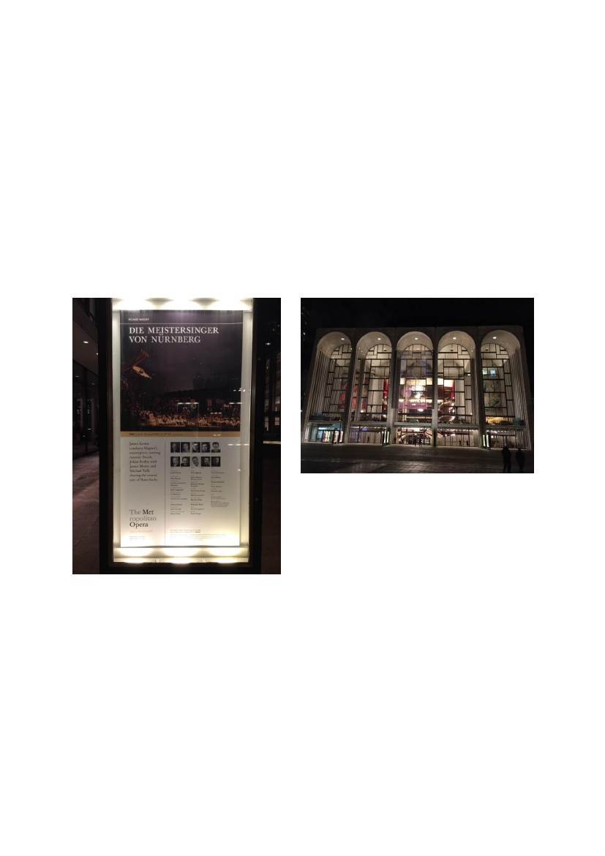
9
opened for Act 2 there was spontaneous applause. Had Mr Wagner been in the audience, no
üdoubt he would have clapped too, given the specific nature of his stage directions in the
libretto
The original choice for Hans Sachs was Johan Reuter. However he decided he did not want to
add Meistersinger to his repertoire, so he was replaced by two alternatives over the eight
performances. For the two performances I saw, Michael Volle was a very convincing and
vulnerable Sachs. While his performance throughout was strong, I particularly liked his
tenderness and humanity in Act 3 Scene 1. The other singer playing Sachs was Met veteran
James Morris. From the audience members I spoke to at the Met (who saw both performers),
the consensus seemed to be that while Morris had the better on-stage presence Volle had the
better voice. In fairness to Mr Morris he is now 68 years old, so full marks to him for
stepping up to the table in this most taxing of roles.
Johan Botha was excellent as Walther. Paul Appleby had real zeal as David and there were
wonderful performances by Johannes Martin Kranzle as Beckmesser and Hans-Peter König
as Pogner. The chemistry and tension between the relevant mastersingers and their
apprentices was electric! There were different views on Annette Dasch. I thought she sang
well, though some audience members commented that her voice was too small for a venue
like the Met. However everybody praised the singing of Karen Cargill as Magdalene
All in all it was a wonderful experience and I was delighted to have the chance to see this
production in the venue it was designed for.
10
Dublin, 13 December 2014
Just four sleeps on, a different continent, country and medium, and it was more of Die
Meistersinger!
The 12.00 noon Matinee (17.00 Irish time) from the Met on 13 December was relayed around
the world. Audiences in Ireland enjoyed the live relay of the opera in 19 venues throughout
the country. I have compared and contrasted live performances and live relay performances in
the past and it never ceases to amaze me how good the live relays are. A live relay is much
more than playing a DVD in a cinema. The sense of community enjoyment and dialogue is
excellent, regardless of the location or medium. I believe the live aspect is an important part
of this experience. If Mr Levine needs a 40-minute break between acts of Die Meistersinger
the Met audience must wait ... and the Irish cinema audience must wait!
There are five points I would like to make on cinema live relays, using my viewings of Die
Meistersinger as an example:
1. Words are important, especially in Wagner operas. The cinema audience can closely
follow the action on stage and appreciate the comedic interactions and nuances as the
text is always simultaneously available on screen. When I was at live performance in
the Met I needed my reading glasses perched at the end of my nose to read the titles
on the seat in front while watching the action on the stage below. The live relay was
much less complicated.
2. The live relay puts the audience in the prime seats with the cameras getting right in on
the action. This worked very well in Act 3 Scene 1 of Meistersinger. The camera in
the cinema focused tightly on Hans Sachs’s workshop, and one could follow the
coaching of Walter and the sublime quintet at the conclusion of the scene. In the Met,
this scene takes up a small part of the stage, because the scene is proceeded and
succeeded by much grander vistas of the streets of Nürnberg and the meadow scene.
This isn’t a criticism of the Met, it is just a case where the cinema vista for Scene 1 is
more focused
3. While I have read about the guilds of Nürnberg, the close-up of the masters’ table in
Act 1 and the procession of the guilds in Act 3 helped me understand the rivalry
between the different professions. On the live relay I could clearly see the hierarchy
and the names.
4. To be seen to be fair, I have to point out one area that was exposed in the live relay.
While Annette Dasch looked great in the live performance, the relay was much closer
in on her face. Her eyes were very prominent and she constantly looked terrified,
especially in Act 3. While some may say this was her acting her part I think it was
more pronounced than that.
5. It is not to everybody’s taste but I find the interval interviews and events very
informative. In this case it was as though Renée Fleming was my personal guide to
the performance. The Met does this better than any of its competitors.
In summary I’m not trying to replace live performances with live relays. Both have their parts
to play and both are complimentary experiences with less overlap than one might initially
imagine. While I really loved the Met live experience on 9 December, I did find that on 13
December I got a greater insight from the live relay as to what Wagner was trying to portray
in Die Meistersinger.
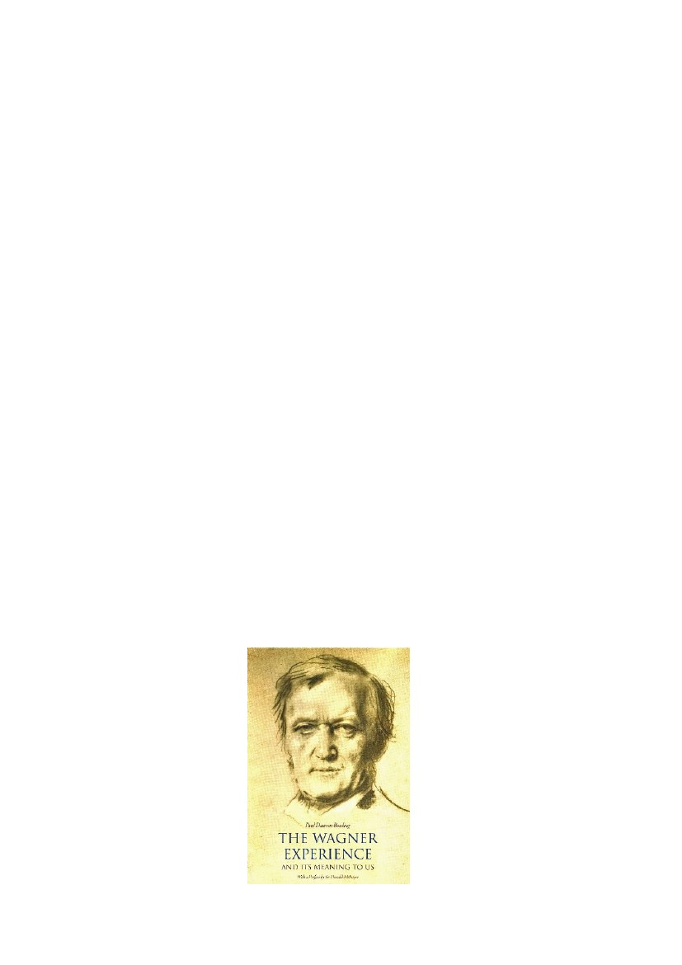
11
Finally
Some excellent performances of Die Meistersinger are available on DVD. The Met Otto
Schenk production was released in 2001 with James Morris as Sachs. There is a Vienna
production from 2008 if you want to see Johan Botha sing Walther, and this is based on the
Otto Schenk production. There is a critically acclaimed Glyndebourne production with
Gerald Finlay, released in 2012. And if you want to see what the future looks like, Stefan
Herheim’s Salzburg Festival production with Michael Volle as Sachs was released in 2013.
This production is destined for the Met before 2019. But if you need a quicker fix The
Mastersingers of Nuremberg (as bearla!), originally a Welsh National Opera production,
opens in London at the English National Opera in February 2015. I’ll be there!
Book Review by Dame Gwyneth Jones
Paul Dawson-Bowling, The Wagner Experience: And its Meaning to Us. 2 vols (Brecon: Old
Street Publishing, 2013).
This set of two wonderful books, beautifully presented, truly makes the ideal gift. But not
only that! They are a ‘must’ to have, as a reference to Wagner’s life and his incredible
compositions and are ideal for placing in the lounge or bedroom for visiting guests to browse
through, or for refreshing one’s memory of the stories, the sources and the lessons of
Wagner’s great dramas, before attending the performance.
We are extremely fortunate to have Paul Dawson Bowling and his lovely wife Elizabeth de la
Porte, who is a superb Harpsichord player and has been teaching at the Royal College of
Music for over fifty years, as two loyal and devoted members of our [London] Wagner
Society.
Paul is a retired General Practitioner from an era when this meant ‘family doctor’, and he
takes us gently by the hand and guides us lovingly through this enormous undertaking of
relating the tempestuous life of Wagner with great enthusiasm, wisdom, humanity and
psychological understanding.
12
His dedication: ‘To My Wonderful Wife Elizabeth Was je ich ersehnt, ersah ich in dir’,
(Everything I ever longed for, I saw in you), Siegmund: Die Walküre Act I, makes it clear to
us that this is a man, enriched by the joy of sharing the holy art of music with his wife and
family and also with all of us.
Literally hundreds of books have been written about Wagner; but there is no other book quite
like this. It is written in a language which is elegant, beautiful, and understandable to all.
One feels that a very dear friend is guiding you through this journey of Wagner’s life, with a
desire to share his own love and admiration for the composer in order than you may also
share his incredible Wagner experience.
He has done tremendous research and delves into every aspect of Wagner’s life and his music
dramas. One constantly discovers things that you may somehow have missed in the past, like
the fact that Wagner had originally intended the scene in Das Rheingold between Wotan and
Erda to be with the three Norns. Also, his descriptions of the wildly intense, sensuous
relationship with Minna is a revelation. They met when he was just 21 years old. She was
three years older than him and was an extremely beautiful woman and a very talented actress.
She went through heaven and hell with him on his various escapades, fleeing because of their
debts, being shot at by border guards, causing their carriage to overturn resulting in Minna
having a miscarriage which was probably the cause of her childlessness afterwards. Also the
near shipwreck on the flight from Riga to London, which was the inspiration for Der
fliegende Holländer. She was so terrified that she begged Richard to lash her to him, so that
they could drown and perish together. No wonder that she became the source and inspiration
for all the heroines in Wagner’s dramas! She was his muse and in her he saw his archetype,
his ideal, the perfect example for Elisabeth, Venus, Elsa, Sieglinde, Brünnhilde, Senta, Eva
and Gutrune. Mathilde Wesendonck became his muse for Isolde when the love between
Wagner and Minna began to fade, but he continued to hope and believe that each new
attraction would bring him that same heightened state of mind and being which Minna had
brought him.
The first Isolde was sung by Malvina Schnorr von Carolsfeld who, after the death of her
husband Ludwig three weeks after singing the première of Tristan, believed that the ghost of
her husband said that she was destined to marry Wagner. She wrote incensed letters to King
Ludwig, complaining about Wagner’s liaison with Cosima after discovering that Cosima was
highly pregnant and was banished by both Wagner and the king. Whilst in Dresden to
perform ‘O Malvina’ I went to visit the family grave of Malvina and Ludwig and discovered
to my astonishment that Minna is buried directly next to it.
Richard and Minna were married for over thirty years but were together for only twenty;
partly because Mathilde Wesendonck and Cosima entered his life. One tends to think of these
two women as being the main loves of Wagner’s life, but this was because Minna was
somewhat banished into oblivion by Cosima, who successfully destroyed many of Wagner’s
letters and made cuts in others.
The Wagner Experience is unique because not only does it give a brief biography of Richard
Wagner, an extensive account of his tumultuous life and excellent, detailed explanations of
the sources and lessons of his great dramas, but it also includes an abundant wealth of
glorious illustrations which are largely determined by the archetypes inherent in Wagner’s
Operas. There are some very unusual sets of cards: ‘Liebig’s Fleisch-Extract’, from a sort of
13
Oxo/Marmite Company which show us how Wagner was popularly presented in Germany
100 years ago and some beautiful pictures showing the style of Wieland Wagner’s
productions, which were very prominent in the years after the re-opening of the Bayreuth
Festival after the war. I was fortunate enough to sing very often in these productions,
especially Der fliegender Holländer, Die Walküre and Parsifal. There are eight of the twelve
incredibly beautiful Richard Wagner illustrations from the original oil paintings by Ferdinand
Leeke (1859–1923) which were painted circa1900–10, a very interesting self-portrait as
Lohengrin by Ludwig Schnorr von Carolsfeld which illustrates to us that he not only sang
these heavy Wagner roles in his twenties (he sang Tristan aged 29 and died shortly afterwards
from a lung disease, not from the strain of singing the role as is often said) but also inherited
his father’s talent for painting. Another surprise picture shows the author’s mother in law
Betsy de la Porte as Waltraute in Die Walküre at Covent Garden in 1935, which conjures up
visions of Hojotohos ringing through the family home and mutual enjoyment sharing
Wagner’s music, and which makes it even clearer why this wonderful book has been written.
However, my favourite pictures are those of Arthur Rackham (1867–1939). They are
incredibly beautiful, highly imaginative scenes from the mythology of The Ring which were
my inspiration to all the various roles that I sang in it: Wellgunde a Rheinmaiden, Ortlinde a
Valkyrie, Sieglinde, Gutrune and Brünnhilde. I would have given anything to have been able
to perform these roles in these costumes and surroundings and am convinced that many of us
would love to see a production in this style again. I would certainly try to create similar
visions with the aid of modern techniques if I ever had the chance to produce a Ring myself.
I have become weary of many of today’s opera productions. If I buy a ticket to see Der
fliegende Holländer I want to see the sea, ships, sailors and spinning wheels, not an office
full of secretaries sitting at their typewriters and I do not want to see Elisabeth going to the
gas chambers in Tannhaüser or any of the other annoyances which simply ignore the
directions in the score, changing the subject of the piece entirely and suggesting that the
producer is superior to the composer.
The public is insulted and treated like idiots who are incapable of forming their own
interpretation of the composer and librettist’s work and its effects on their daily lives and
morals. It is not because I am old fashioned. To the contrary. I am simply sick of the
disgraceful way that precious works of art are being abused by many of today’s producers
who often admit that they have no knowledge of the art of opera and are unable to read
music. It would seem that their main aim is to create something which is going to arouse
protests and scandal and has nothing whatsoever to do with the contents of the score, which
makes them ‘the talk of the town’ and enhances their careers.
Many avid opera-goers have given up trying to show their disagreement by booing and are
simply not going to such performances any more, which is made clear by the empty seats in
many opera houses nowadays. In Bayreuth tickets are now easy to obtain on the internet and
sometimes, even on the day of the première at the box office. This I find very worrying
because if the public is lost, it is not so easy to get them back again!
After decades of placing operas into ‘our time’ with blue jeans, ugliness and the desecration
of sex it has become outdated and I feel that it is necessary to return to the truth of the score.
This applies, of course, not only to Wagner’s dramas; but to opera staging in general. It
would also help the new generation to gain knowledge of the various epochs, such as
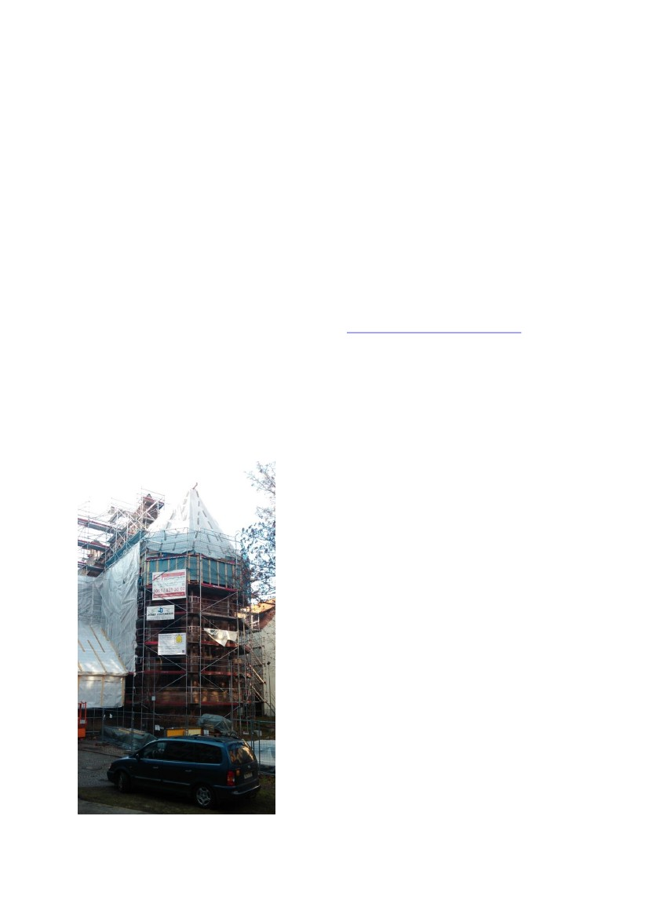
14
Medieval, Rococo and Biedermeier. One only has to look at the popularity of Lord of the
Rings to know that they would also welcome this transition,
The Wagner Experience reminds us of the original didactic aspects of the dramas, which
encourage and inspire us to seek our own understanding and morals through the wise lessons
and advice in the text and action, which enables us to have life more abundantly enriched by
the enormous power and beauty of the music, which often transports us to heavenly spheres.
I hope that Paul Dawson Bowling’s The Wagner Experience will reach and inspire new
audiences, as well as reviving the enthusiasm of mature Wagner lovers. This is like having
three books in one, because it places Wagner’s life, his work and a fabulous array of exquisite
illustrations before us in a nutshell. We must be grateful that he has so generously shared his
‘Wagner Experience’ with us and I am sure that everyone who reads it will be filled with
renewed admiration and understanding for this great composer and his works.
The book’s normal recommended retail price is £35 but I have established that signed copies
are available £5 cheaper and post free in the UK at www.thewagnerexperience.co.uk. The
book is also available from Blackwells and all good bookshops, and everywhere online, also
as Kindle version.
Our thanks to Dame Gwyneth for sending us her review.
Church of St Martha, Nuremberg
Barbara and I spent Christmas morning strolling
around Nürnberg, and were looking forward to
seeing St Martha’s church, where the
mastersingers rehearsed in the days of Hans
Sachs. We had not heard about the disastrous fire
of 5 June 2014 which almost completely burned
out the church. The good news, though, is that it
is being completely restored by the German
Lutheran Church.
Judging by the breath-taking Frauenkirche in
Dresden, completely rebuilt in recent years after
its total destruction through the attentions of the
RAF and USAF, St Martha’s too will soon be as
good as new.
Apart from that, we had ein Wagnerloses
Weihnachts – though we did see as near perfect a
production as you are likely to find of Der
Rosenkavalier at the Semperoper, Dresden, with
Anja Harteros (Marschallin), Sophie Koch
(Octavian) and Peter Rose (Ochs), and the
Dresden Staatskapelle conducted by Christian
Thielemann. – Stephen Mennell

15
Wagner on Lyric FM
Following Michael Murphy’s terrific talk to the WSI on 15 January about ‘Public perceptions
of Wagner performances in Ireland, 1860–1920’, Jarlath Jennings pointed out that Michael’s
two broadcast talks on a similar topic, broadcast on RTÉ Lyric FM in 2013 and repeated in
2014, are still available on the Lyric FM website. As Jarlath says, ‘the talks are excellent,
well-researched and well-illustrated, and there are also other Wagner pieces, including the
recent Met recording of Die Meistersinger.’
The programmes can be found by typing the words “Wagner podcasts” in the search box, but
that gives a very long list of past programmes through which one has to scroll down
manually.
I checked further with Michael. He says:
If you google ‘Wagner’s Music in Ireland Lyric feature lyric fm’, you’ll get a few
pages about my programmes, but they don’t take you to the programmes per se:
Prog 1: http://www.rte.ie/lyricfm/the-lyric-feature/programmes/2013/0927/476941-
the-lyric-feature-friday-27-september-2013/?clipid=1320368
Prog 2: http://www.rte.ie/lyricfm/the-lyric-feature/programmes/2013/1004/478479-
the-lyric-feature-friday-4-october-2013/
You’ll have to click on the ‘Listen’ button which opens the ‘RTE Radio Player’ and
click in ‘Search in the Player’ on the bottom right-hand corner.
Convoluted, and I’m sure there’s an easier way of doing it, but copying the link from
the Player itself doesn’t work as I found out last night as I wanted to play some
extracts from the programmes.
However, it should be noted that RTÉ does not use the word ‘podcast’ in the usual sense to
mean something that can be downloaded: here the term means only that one can listen to the
streamed content online. Wikipedia seems to give this as an alternative meaning, but it is not
what I understand by a podcast.
As you will gather, the Lyric FM website is a mess (like most other aspects of Lyric FM), but
if you have the necessary patience, there are riches to be found there. So don’t be too deterred
by the battles that Jarlath, Michael and I have had with the website.
Stephen Mennell

