NEWSLETTER SEPTEMBER 2018

CHAIRMAN’S INTRODUCTION

Dear Member,

We hope you enjoyed what was a beautiful summer in Ireland albeit one that challenged the gardeners among us. Now as we face into the autumn season it is time to recommence our meetings. We have as ever tried to organise some variety around the talks. Though we have yet to confirm dates we are hoping to have Derek Watson give a one-day seminar on Rienzi in 2019, which those of us who really enjoy Derek’s seminars will be something to look forward to. Of course, since we last met Jennifer Davis has had a great triumph at the Royal Opera as Elsa in Lohengrin. To mark this, we intend to hold as our opening meeting a reception for her, which will also involve a discussion with her. We are very grateful to Jennifer for making time to attend our meeting. Unfortunately, though Jennifer is looking forward to attending we are having problems finalising a date but should do so shortly.

It will be in late September or early October and we will send out a message as soon as we know.

If you have any ideas for talks or activities for the Society, please contact any member of the Committee. We are always looking for new ideas. Lastly, I would encourage you to bring along some friends to the meetings with the idea of encouraging them to join the Society.
We look forward to seeing you at meetings and catching up.

Yours

Anthony.

AUTUMN 2018 TALKS

ALL MEETINGS AT 8PM IN THE UAC

SEPTEMBER-OCTOBER JENNIFER DAVIS TBC

WEDNESDAY 17 OCTOBER CHRISTOPHER MORRIS
“Invisible Theatre: Orchestral Interludes in Post-Wagnerian Opera”

MONDAY 19 NOVEMBER ROBERT MCALLISTER
Recital

WEDNESDAY 12 DECEMBER CHRISTMAS EVENT
A Conversation with Suzanne Murphy

JENNIFER DAVIS

Irish singers seem to be mastering the art of stepping into premieres and making sensational debuts in roles. First there was Tara Erraught stepping as Romeo in Munich and triumphing and this summer Jennifer Davis took over the role of Elsa at the Royal Opera in their new production of Lohengrin. In both cases, there was considerable negative comment in advance regarding the importance of the house and a major role in a new production being given to a relative unknown. We can only imagine the psychological pressure on the first night. It says much for the character of Jennifer that she took it all in her stride and despite being opposite some very famous colleagues she not only held her own but triumphed and many of those who had doubted her on blogs later admitted she was the outstanding singer of the production. The press were also universally positive in their praise. To quote the Editorial in Opera Magazine:
“In the same issue as we sadly mark the farewell of a great operatic artist, Mariella Devia, taking her leave with Norma at La Fenice, we also signal the arrival of a major new talent, Jennifer Davis, in her debut as Elsa at Covent Garden”

And in the review by John Allison “it was an accident of casting that delivered the best singing of the evening……a career-defining performance…she took the vocal honours with her evenly produced silvery tone”
We are delighted Jennifer will attend our meeting in September/October.
PAUL McNAMARA

Paul, an old friend of the Society, gave recitals in Limerick and Dublin (Hugh Lane Gallery) over the summer. The Society made a small contribution towards these which was acknowledged in the programme and at the Hugh Lane Gallery by Paul who spoke very highly of the Society and our support for young singers and encouraged those present to look up the Society. We are very grateful for this promotion. Paul is to sing his first Siegfried in Götterdämmerung next June in Würzburg and we wish him every success. I saw Nixon in China there this year and thought outstanding as a production. The same producer will be doing the Wagner and I am interested to see what he will make of Götterdämmerung.

OPERA COLLECTIVE

The Society also continued to support the Opera Collective by taking an advertisement in the programme for the Return of Ulysses. Monteverdi might be quite a musical distance from Wagner but it is important we support the young artists whom Opera Collective gives an opportunity to develop and be seen on an Irish stage. Jennifer Davis for example is an alumnus of a past production, Benjamin Britten’s The Rape of Lucretia. The Monteverdi was performed to great acclaim at Kilkenny Arts Festival and a complete Gesamtkunstwerk.

TRIPS 2019

We have tickets for the productions of Tannhauser in Amsterdam and Tristan in Brussels in May. The plan would be to fly to Amsterdam and then train to Brussels . If those travelling are interested, we might divert between the opera to Bruges. The details of the operas are as follows:

Tannhäuser (Amsterdam)
Conductor Marc Albrecht Director Christof Loy Sets Johannes Leiacker Costumes Ursula Renzenbrink Lighting Olaf Winter Choreographer Christof Loy Chorus master Ching-Lien Wu Dramaturge Klaus Bertisch ~ Hermann Stephen Milling Tannhäuser Daniel Kirch Wolfram von Eschenbach Björn Bürger Walther von der Vogelweide Attilio Glaser Biterolf Kay Stiefermann Heinrich der Schreiber Lucas van Lierop Reinmar von Zweter Cody Quattlebaum Elisabeth Svetlana Aksenova Venus Ekaterina Gubanova

Tristan Und Isolde (Brussels)
Conductor Alain Altinoglu Director Ralf Pleger Sets Alexander Polzin Costumes Wojciech Dziedzic Lighting John Torres Choreographer Fernando Melo Chorus master Martino Faggiani ~ Tristan http://www.operabase.com/a/Christopher_Ventris/3228 Bryan Register König Marke Franz-Josef Selig Isolde Ann Petersen Kurwenal Andrew Foster-Williams Brangäne Nora Gubisch / Eve-Maud Hubeaux Melot/ Ein Steuermann Wiard Witholt Ein Hirt/ Ein Junger Seemann Ed Lyon

If you are interested in attending please send an email to tanthonylinehan@gmail.com as soon as possible.

RICHARD WAGNER – COMPLETE WORKS

Leipzig Oper have written to inform us that they will perform the complete works of Wagner over three weeks from the 21 June to the 14th July 2022 – so plenty of notice. We understand the performances will include the early works as well as the major compositions. Certainly an interesting prospect if one had the stamina!!
PARSIFAL – MUNICH-VERONICA DONOGHUE

Director: Pierre Audi
Sets: Georg Baselitz

Munich opera festival opened this year with a new production of Parsifal and I was lucky to secure a ticket for the performance on July 5th.

Georg Baselitz is a well known German painter, sculptor and graphic artist, but until I attended the performance the name was unknown to me I am afraid. Since 1969 he paints his subjects upside down. 20 years after World War II he created a series of “Heroes” which typically appear alone in a barren landscape. I have also read that he is influenced by the Columbian Artist Fernando Bolero’s murals known for depicting people and figures in large exaggerated volumes. This perhaps goes some way towards explaining why this entire production was so very dark and for the most part black and white and also the very ugly costumes which were worn by the knights and flowermaidens.

In Act I the opening music is played with a painted curtain down, showing 4 decaying bodies lying sideways. When the curtain is raised we see a bare dark forest with some trees, Gurnemanz is sitting on our left and Kundry lies under a curved horse skeleton on our right. There is no great hall of Monsalvat – instead a tent-like structure made of wooden planks. When Parsifal appears it is with a large white fluffy swan which he has just killed. When Amfortas unveiled the Grail he held high a bleeding Heart and the knights took part in the Grail ceremony in suits with exaggerated flesh as if naked. As the Act draws to a close the forest trees collapse.

In Act II Kingslor and Kundry crawl out from under the painted curtain but on this occasion the 4 decaying bodies are upside down and they sing the first part of the act kneeling/sitting on the floor.
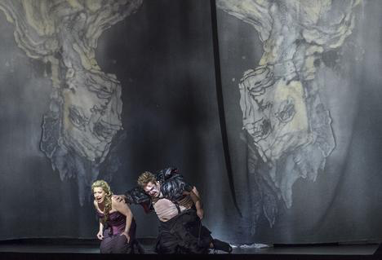

When the main curtain rises we see another “collapsed” curtain which rises to look like a wall with an uneven central opening and which collapses again at the end of the act. There are no luxurious flowers or vegetation – just 4-5 white rocks placed in front of the “wall”.
The flowermaidens were dressed in ugly suits with over-proportioned breasts, abdomens, buttocks etc.

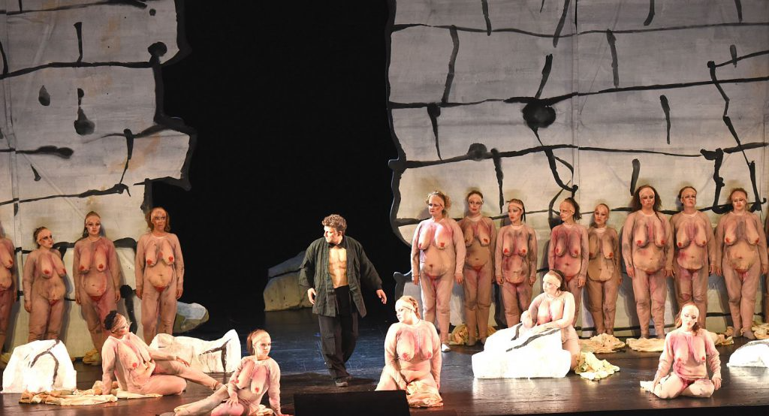

In Act III the scene is exactly as in Act I without the horse skeleton and with the addition of a small campfire . The trees had again reached their normal height.

After the baptism of Kundry came the only colour in the entire set – a brief flood of purple light.

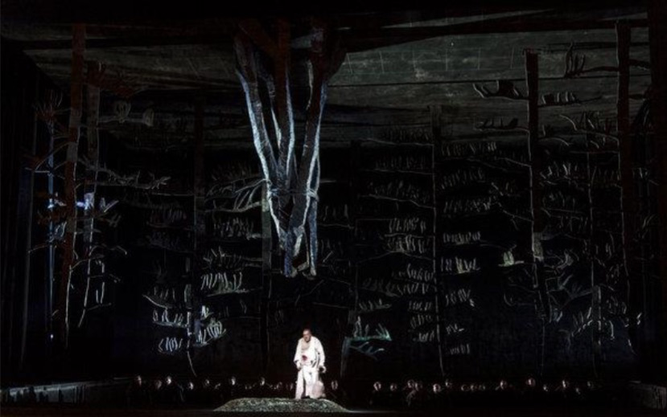

However, the production did not interfere with my enjoyment of the performance but the relevance of many aspects, especially the painted curtains, still remains a mystery.

Munich assembled a sublime cast for the occasion. Jonas Kaufmann sang an excellent and convincing Parsifal and was in magnificent voice especially in the second act. Wolfgang Koch was an excellent Kingsor with a powerful voice. Rene Pape has been singing the role of Gurnemanz for many years and may be the best interpreter of the role today – he was truly outstanding. Nina Stemme said in a recent interview that one needs to sing the role of Kundry in more than a dozen staged performances in order to fully inhabit it – she demonstrated this with her wonderful performance. Christian Gerharer’s Amfortas was a revelation – his singing was excellent as would be expected from a star lied singer but in addition his acting was sensational. The Chorus of Flowermaidens and Knights could not be surpassed. The Orchestra under the wonderful conductor, Kirill Petrenko, were rivetting – he paid attention to every detail and the balance between the voices and the orchestra was carefully planned throughout. Petrenko never once covered the singers and as all speak fluent German their diction was uniformly excellent.

One could hear a pin drop during the entire performance and I did not hear as much as a single cough from the audience. At the final curtain there were several seconds of silence before the applause erupted, a testament to the interpretation of the conductor, orchestra and singers – all beyond comparison!

